**LEBANESE AMERICAN UNIVERSITY**

**USAID – HIGHER EDUCATION SCHOLARSHIP PROGRAM**

**HES - Volunteering Program Verification Form**

This form is to be used to document volunteering hours. If a student volunteers for multiple organizations, a separate form must be used for each organization. **This form must be turned in by the 28th of each month, the latest.**

I certify that the scholar Marwa Ali Omama completed a total of 5 hours of service at Life Sculptor.

The hours were completed hours as per the below:

Hours # 0 (date) _30/09 – 5/10_ (initials of supervisor) __A.K.___

Hours # 0 (date) _7/10 – 11/10_ (initials of supervisor) __A.K.___

Hours # 5 date) _14/10 – 18/10 (initials of supervisor) __A.K.___

Hours # 0 date) _21/10 -25/10 (initials of supervisor) __A.K.___

Brief description of the activities the scholar performed or participated in:

To research the topic of the neuroscience behind decision making, I began by identifying key themes and concepts related to the subject. I utilized academic databases, peer-reviewed journals, and reputable online resources to gather relevant information. I focused on understanding the decision-making process, the roles of various brain regions, and the impact of cognitive biases.  
  
As I collected ideas, I organized them into categories, ensuring I captured the essential elements of each aspect of the topic. I took detailed notes, highlighting important studies and theories, which helped me synthesize the information effectively.  
  
Once I gathered sufficient content, I drafted the findings in a Word document. I structured the document with clear headings and subheadings for easy navigation. Each section included concise descriptions and key points, ensuring that the details were well articulated.In addition, I paid special attention to clarity and coherence, making sure that the information flowed logically.  
  
Furthermore , throughout this process, I revised and refined the text, focusing on grammar and style to enhance readability. This careful approach not only strengthened my understanding of the topic but also ensured that the final document was polished and informative and i have done the same steps for my research about the topic that talks about role of technology in education.

Written feedback about the scholar’s performance:

Marwa shows strong research skills and effectively organizes her findings. However, she lacks experience in creating PowerPoint presentations, which could improve her ability to communicate her research visually. Overall, her analytical approach and commitment to clarity are commendable.

Please rate the overall performance of the scholar at your organization:

|  |  |  |  |
| --- | --- | --- | --- |
|  | Mastery (5) | Proficient (3) | Emerging (1) |
| **Problem solver** | X |  |  |
| **Engaged & Committed** | X |  |  |
| **Open-minded & multicultural** | X |  |  |

Signature

& stamp

__________________________

_

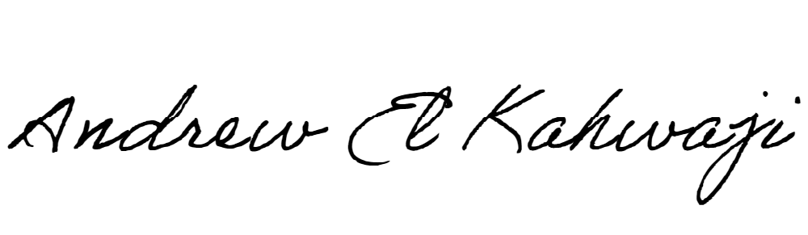

Printed Name _Andrew El Kahwaji_

Date __26/10/2024___

Email __andrew.lifesculptor.coo@gmail.com __

Phone __+961 71 914 378__

**LEBANESE AMERICAN UNIVERSITY**

**USAID – HIGHER EDUCATION SCHOLARSHIP PROGRAM**

